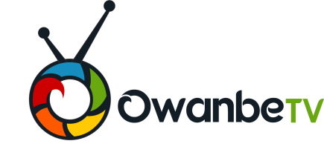

**+43, Oremeta Street, Ojodu – Berger, Lagos  
08165314466, 08091597625**

**ADVERTISING RATE FOR OWAMBE TV**

|  |  |
| --- | --- |
| **Posting of Advert Pictures** | **N5,000.00** |
| **Posting Advert Videos** | **N10,000.00** |
| **Live Coverage of Events** | **N200, 000 – Upward** |
| **Documentary** | **N10,000** |
| **Programme Sponsor** | **N2,000 per show**  **N50,000 per section** |
| **Programme Ownership** | **N100,000 – N200,000** |
| **Independent Producers** | **Free** |